**Planificación de actividades**

**del proyecto:**

**Umai System**

Elaborado por:

Antonio Caro Guerrero

Eduardo Enríquez Santos

Erika Lizbeth Gómez Ramos

Adriana Guadalupe Morales Mendoza

**Actividades**

En la siguiente tabla se muestra cada actividad a desarrollar para el software Umai System, en esta se describe cada actividad.

|  |  |  |  |
| --- | --- | --- | --- |
| **Abrv.** | **Requerimiento no funcional** | **Dependencia** | **RF** |
| RNF1 | Diseño de base de datos | - |  |
| RNF2 | Crear base de datos | RNF1 |  |
| RNF3 | Conectar base de datos | RNF2 |  |
| RNF4 | Maquetación | RNF3 |  |
| RNF 5 | Validar datos | - |  |
| RNF 6 | Crear modulo CRUD | RNF3 |  |
| RNF7 | Crear usuario | RNF3 | PV1 |
| RNF8 | Modificar usuario | RNF3, RNF7 | PV1 |
| RNF9 | Eliminar usuario | RNF3,RNF7 | PV1 |
| RNF10 | Modificar permisos de usuario para PDV | RNF3,RNF7 | PV2 |
| RNF11 | Actualizar estado de la venta pagado | RNF3 | PV2 |
| RNF12 | Mandar a imprimir, con el formato requerido | RNF11 | PV2 |
| RNF13 | Guardar venta en la BD con estado activo | RNF3,RNF5 | PV3 |
| RNF14 | Modificar venta | RNF5,RNF12,RNF13 | PV3 |
| RNF15 | Aplicar descuento en venta | RNF12, RNF13 | PV4 |
| RNF16 | Aplicar cancelación de venta | RNF3, RNF13 | PV5 |
| RNF17 | Modificar en la BD eliminando un reg. | RNF3, RNF16 | PV5 |
| RNF18 | Cargar interfaz del piso | RNF3, RNF4 | PV6 |
| RNF19 | Cargar el edo. De los elementos | RNF3, RNF5,RNF18 | PV6 |
| RNF20 | Agregar un producto | RNF3,RNF5 | S1 |
| RNF21 | Modificar producto | RNF3,RNF5,RNF20 | S1 |
| RNF22 | Eliminar producto | RNF3,RNF5,RNF20 | S2 |
| RNF23 | Agregar información del personal | RNF3,RNF5 | S2 |
| RNF24 | Modificar información del Personal | RNF3,RNF5 | S2 |
| RNF25 | Eliminar información del Personal | RNF3,RNF5 | S3,s4 |
| RNF26 | Agregar receta estándar | RNF3,RNF5 | S3,s4 |
| RNF27 | Modificar receta estándar | RNF3,RNF5 | S3,s4 |
| RNF28 | Eliminar receta estándar | RNF3,RNF5 | S3,s4 |
| RNF29 | Generar PDF | - |  |
| RNF30 | Informe de ventas | RNF3,RNF5,RNF15,RNF28 |  |
| RNF31 | Informe de inventarios | RNF3,RNF5, RNF28 |  |
| RNF32 | Informe de entradas y salidas | RNF3,RNF5, RNF28 |  |
| RNF33 | Informe de producto mas vendidos | RNF3,RNF5, RNF28 |  |
| RNF34 | Informe de ventas detalladas | RNF3,RNF5, RNF28 |  |
| RNF35 | Informe de productos bajo de stock | RNF3,RNF5, RNF28 |  |
| RNF36 | Agregar proveedores | RNF3,RNF5 |  |
| RNF37 | Modificar proveedores | RNF3,RNF5,RNF36 |  |
| RNF38 | Eliminar proveedores | RNF3,RNF5,RNF36 |  |
| RNF39 | Maquetación web |  | W1 |
| RNF40 | Conectar BD con sistema de escritorio |  | W1 |
| RNF41 | Diseño de sistema de encuesta |  | W3 |
| RNF42 | Diseño de sistemas de usuarios |  | W2 |

En la siguiente tabla se muestran los tiempos que tardará cada actividad en desarrollarse

|  |  |  |  |  |
| --- | --- | --- | --- | --- |
| **Fecha Inicio** | **Abrv.** | **Dependencia** | **Tiempo + holgura** | **Hitos** |
| 23/03/15 | RNF01 | - | 5 | M1 |
| 06/04/15 | RNF02 | RNF01 | 2 | M2 |
| 08/04/15 | RNF03 | RNF02 | 2 | M3 |
| 10/04/15 | RNF04 | RNF03 | 5 | M4 |
| 17/04/15 | RNF05 | - | 3 | M4 |
| 22/04/15 | RNF06 | RNF03 | 5 | M5 |
| 29/04/15 | Usuarios(RNF07,RNF08,RNF09) |  | 3 | M6 |
| 04/05/15 | Receta(RNF26, RNF27, RNF28) |  | 3 | M6 |
| 07/05/15 | Producto(RNF20, RNF21, RNF22) | RNF03 | 3 | M6 |
| 12/05/15 | Proveedores (RNF36, RNF37, RNF38) | RNF11 | 3 | M6 |
| 15/05/15 | Pruebas de funcionamiento | Usuarios, Receta, Producto, Proveedores | 3 | M6 |
| 20/05/15 | RNF18 | RNF03, RNF04 | 3 | M10 |
| 25/05/15 | RNF13 | RNF03, RNF05,RNF18 | 1 | M7 |
| 26/05/2015 | RNF19 | RNF03,RNF05,RNF20 | 1 | M11 |
| 27/05/2015 | RNF11 | RNF03,RNF05 | 1 | M8 |
| 28/05/2015 | RNF14 | RNF03,RNF05 | 1 | M9 |
| 29/05/2015 | RNF16 | - | 1 | M12 |
| 01/06/2015 | RNF15 | RNF03,RNF05, RNF15,RNF28 | 1 | M11 |
| 02/06/2015 | RNF12 | RNF03,RNF05, RNF28 | 5 | M11 |
| 09/06/2015 | RNF29 | RNF03,RNF05, RNF28 | 5 | M12 |
| 16/06/2015 | RNF30 | RNF03,RNF05, RNF28 | 3 | M13 |
| 19/06/2015 | RNF31 | RNF03,RNF05, RNF28 | 3 | M13 |
| 24/06/2015 | RNF32 | RNF03,RNF05, RNF28 | 3 | M13 |
| 29/06/2015 | RNF33 | RNF03,RNF05,RNF36 | 3 | M13 |
| 02/07/2015 | RNF34 |  | 3 | M13 |
| 07/07/2015 | RNF35 |  | 3 | M13 |
| 10/07/2015 | RNF39 |  | 10 | M14 |
| 24/07/2015 | RNF40 |  | 2 | M15 |
| 28/07/2015 | RNF41 |  | 10 | M15 |
| 11/08/2015 | RNF42 |  | 5 | Fin |
| 18/08/2015 | Total de días | | 98 |  |

**Hitos**

|  |  |  |
| --- | --- | --- |
| **Abrv.** | **Fecha de entrega** | **Dependencia** |
| M1 | 30/03/15 | RNF01 |
| M2 | 07/04/15 | RNF02 |
| M3 | 13/04/15 | RNF03 |
| M4 | 21/04/15 | RNF04, RNF05 |
| M5 | 28/04/15 | RNF06 |
| M6 | 19/05/14 | Usuarios, Receta, Producto, Proveedores |
| M7 | 25/05/15 | RNF13 |
| M8 | 27/05/15 | RNF11 |
| M9 | 28/03/15 | RNF14 |
| M10 | 29/05/15 | RNF18 |
| M11 | 22/05/15 | RNF15, RNF19 |
| M12 | 08/06/15 | RNF12, RNF16 |
| M13 | 15/06/15 | RNF30, RNF31, RNF32, RNF33, RNF34, RNF35 |
| M14 | 09/07/15 | RNF39 |
| M15 | 23/07/15 | RNF40, RNF41 |
| Fin | 18/08/15 | RNF42 |

Días hábiles: Lunes – Viernes

Descansos: Sábado y domingo

**Red de actividades**

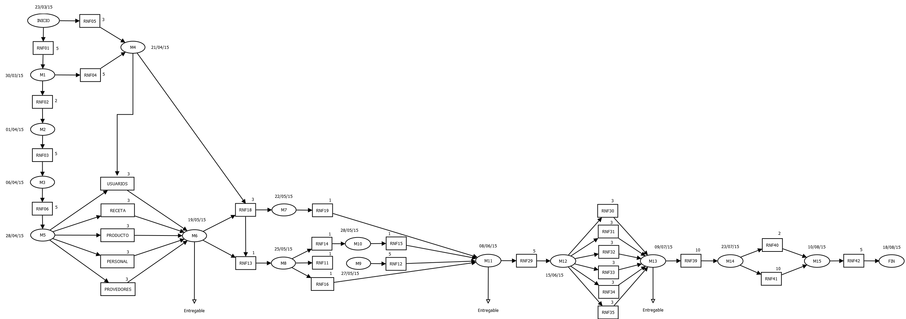

Ruta critica

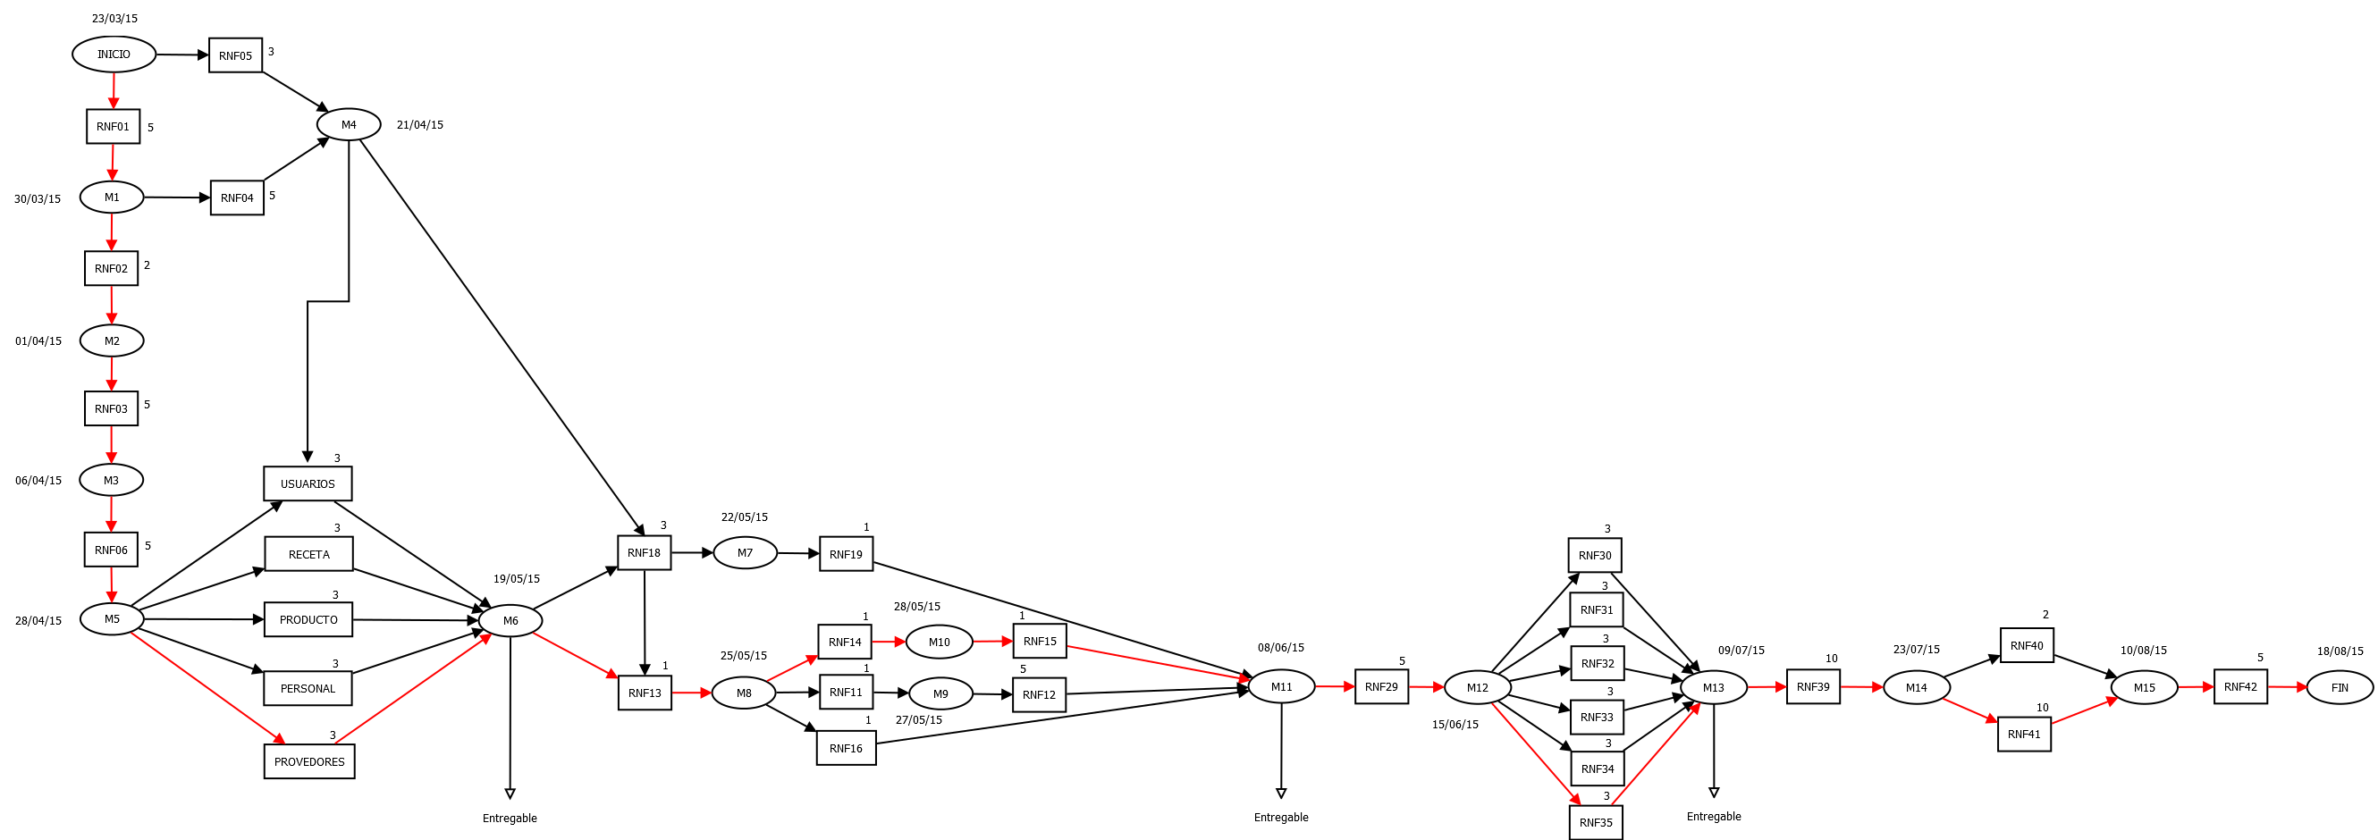

**Diagrama de Gantt**

